|  |  |
| --- | --- |
| Name | M.Faizan Azam, Muhammad Asad |
| Reg. # | 2019-EE-381,2019-EE-383 |
| Marks |  |

Experiment # 9

**Colpitts and Hartley Oscillator**

# Objectives:

* To study and design the Colpitts oscillator.
* To study and design the Hartley oscillator.

# Apparatus:

Op Amp 741, Capacitors, Resistors, inductor, DMM, CRO, Function Generator, Jumpers, Connecting wires, bread board

# Theory:

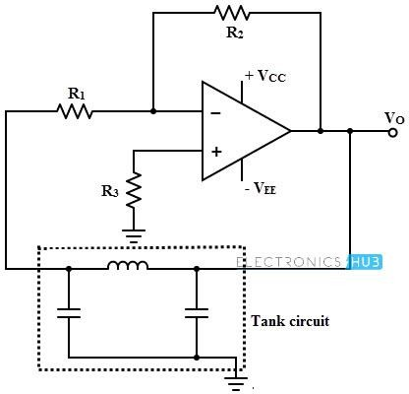

Fig no:1

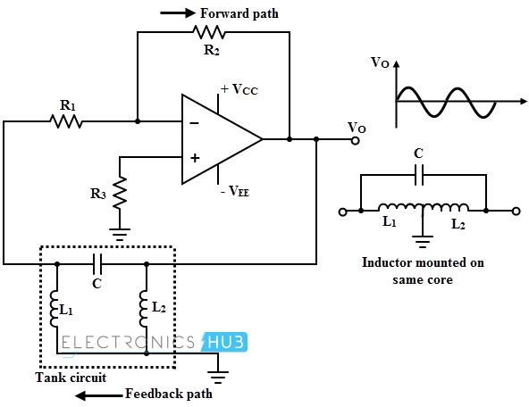

Fig no:2

# General Procedure:

1. ***Colpitts oscillator:***

## fo=1/2𝜋√𝐿𝐶T

* + Connect the circuit as shown in fig (1) with given values of inductor and capacitors and draw the output and measure the fo.
  + Without changing the values of capacitors vary the inductor value and measure the output frequency in each case.
  + Fixed the value of inductor and first capacitor and vary the second capacitor value and find out the output frequency in each case.
  + Fixed the value of inductor and second capacitor, vary the first capacitor value and find out the output frequency in each case.

# Hartley Oscillator:

## fo=1/2𝜋√(𝐿1 + 𝐿2)𝐶

* + Connect the circuit as shown in fig (2) with given values of inductors and capacitor and draw the output and measure the fo.
  + Without changing the values of inductors vary the capacitor value and measure the output frequency in each case.
  + Fixed the value of capacitor and first inductor, vary the second inductor value and find out the output frequency in each case.
  + Fixed the value of capacitor and second inductor, vary the first inductor value and find out the output frequency in each case.

# Design:

Design the colpitts and hartley oscillator with given values of inductor and capacitors and find out the frequency at each case using the above formula and compare it with practical results

# Circuit:

1. ***Hartley oscillator:***

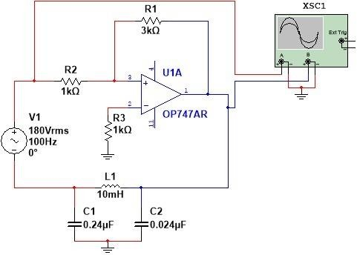

***Calculations:***

***Graph:***

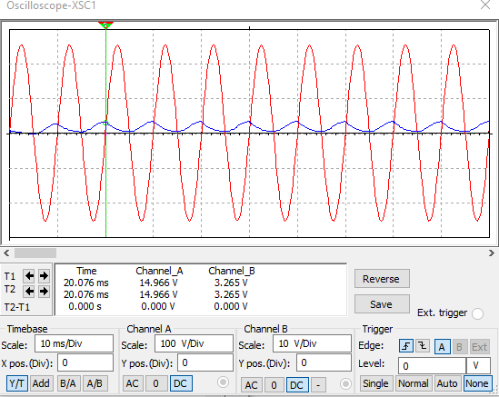

***Result:***

|  |  |  |  |  |  |
| --- | --- | --- | --- | --- | --- |
| Sr.# | **Capacitor** | **Inductor (L1 )** | **Inductor (L2 )** | **fo(theoratical** | **fo(Prac)** |
| 01 | 1 | 14 | 14 | ***30*** | ***33.5*** |
| 02 | 1 | 4 | 4 | ***55*** | ***52*** |
| 03 | 1 | 2 | 2 | ***78*** | ***75*** |

1. 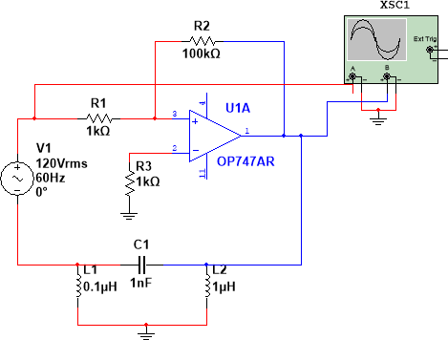***Colpitts oscillator:***

***Calculations:***

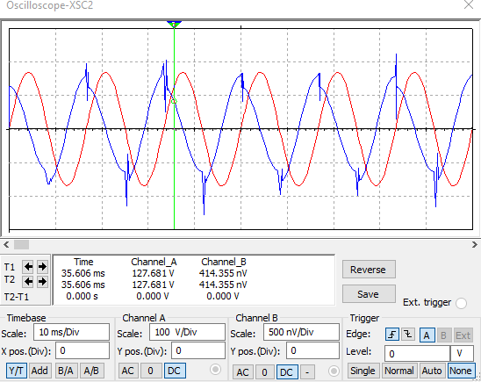***Graph:***

***Result:***

|  |  |  |  |  |  |
| --- | --- | --- | --- | --- | --- |
| Sr.# | **Capacitor (C1 )** | **Capacitor (C2 )** | **Inductor** | **fo(theoratical** | **fo(Prac)** |
| 01 | 14 | 14 | 4 | ***30*** | ***33*** |
| 02 | 4 | 4 | 4 | ***55*** | ***51*** |
| 03 | 2 | 2 | 4 | ***72*** | ***68.5*** |

***Questions:***

### Colpitts oscillator uses which type of feedback? Why?

Colpitts oscillator uses positive feedback for oscillation. The feedback is provided through a capacitor voltage divider tank circuit to the amplifying element.

### What is gain (β) of colpitts oscillator?

In oscillators using positive feedback it is important that amplitude of the oscillator output remains stable. Therefore, the closed loop gain must be 1 (unity). In other words, gain within the loop (provided by the amplifier) should exactly match the losses (caused by the feedback circuit) within the loop.

### What is the formula of Q of β network and also right its range?

Q-factor: In LCR Circuit, the ratio of resonance frequency to the difference of its neighbouring frequencies so that their corresponding current is 1/2 times of the peak value, is called Q-factor of the circuit. Formula: Q=R1CL.

### why can't we use LC oscillator for low frequency oscillations?

If we want to design a oscillator for low frequency we have to choose the values of inductor and capacitor to be large. As we know large value capacitors are bulky and costly and hence they aren't used. This is the reason why we won't use LC oscillator for lower frequency.

### Which type of feedback is used by Hartley oscillator?

The feedback used in Hartley oscillator is Voltage series feedback.